Therapist search notes

You may find it helpful to use this sheet to make notes on potential therapists you want to work with, to compare what is being offered and help you to make a decision about who you’d like to choose to work with.

When you seek psychological therapy, please be aware that in the UK psychotherapy is an unregulated profession which means that anyone – trained or not – can legally call themselves a therapist, counsellor or psychotherapist. Accreditation with an appropriate professional body for therapists (for example, the British Association for Behavioural and Cognitive Psychotherapies (BABCP) for CBT therapists – www.babcp.com) guarantees that you will be speaking with a therapist who is suitably qualified and experienced to provide therapy. Should you decide to work with an unaccredited therapist it would be advised to ask to check their qualifications, at a minimum. For further information about finding alternative therapy, and about accreditation, please see the following webpage: https://www.synergypsychotherapy.co.uk/alternative-private-therapy
Please also be aware that people can be members of accrediting bodies but that this does not mean they are accredited. To check if a CBT therapist is accredited with the BABCP you can use their CBT register here – www.cbtregisteruk.com

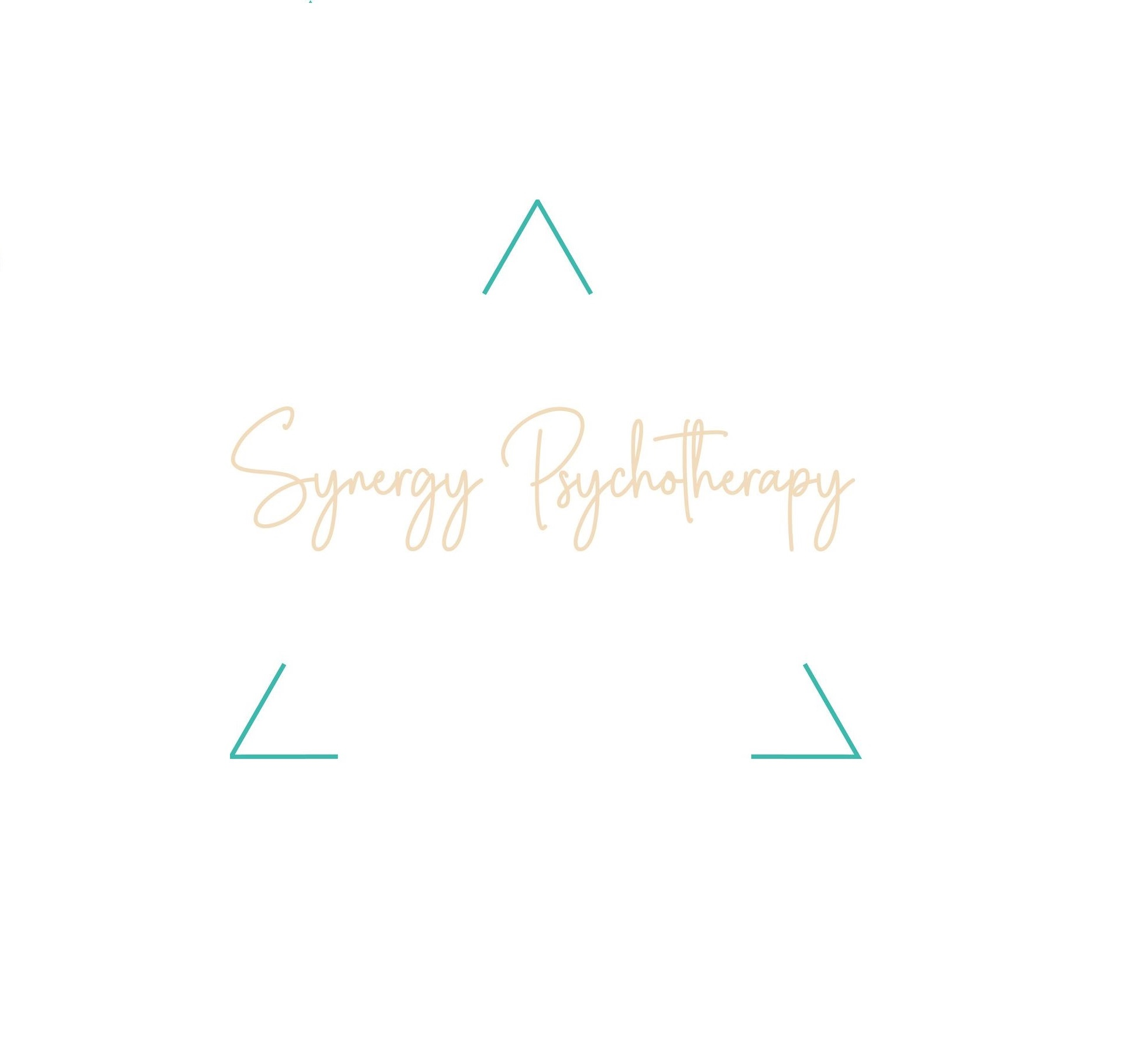

© Copyright. 2026. Synergy Psychotherapy.

Therapist | Work with:  - Adults  - My difficulties  OR offer an assessment | Offer type of therapy I’m looking for, e.g. CBT | Clinic distance | Fees | My questions | How I feel from talking to therapist
Charlotte Shaw, Synergy Psychotherapy | Yes  Yes – special interest in OCD  Offers assessment | Yes | 2 miles | Free consult  £160 first appointment and report  £90 60 mins  £135 90 mins | Do you treat OCD with ERP? – Yes | She seemed knowledgeable, professional and warm. I felt cared about and got a good feeling

© Copyright. 2026. Synergy Psychotherapy.

